3.4 Program Analysis

Description
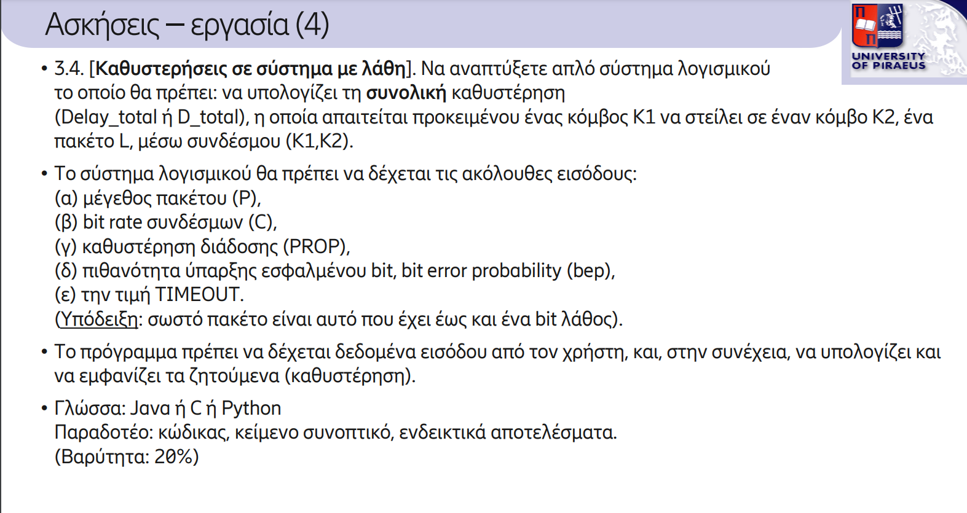

This Python script calculates the total delay (D_total) involved in transmitting a packet over a network link, factoring in the packet size, bit rate, propagation delay, bit error probability, and retransmission timeout. The primary goal is to model a realistic transmission scenario, including the effect of bit errors and the need for retransmissions. The total delay is crucial for understanding network performance, especially in environments with high error rates or limited bandwidth. The script ensures that all necessary parameters are validated before computation, and it handles edge cases like high bit error probabilities to prevent unrealistic or erroneous results.

Input

The script requires five key inputs from the user: Packet Size (P), Bit Rate (C), Propagation Delay (PROP), Bit Error Probability (bep), and Timeout (TIMEOUT). Each input is carefully validated to ensure it meets the necessary criteria for accurate calculations. The Packet Size (P) and Bit Rate (C) must be positive values, as negative or zero values would result in nonsensical delay calculations. The Propagation Delay (PROP) must be non-negative, reflecting the physical nature of network communication. The Bit Error Probability (bep) must be strictly between 0 and 1, as a value outside this range is invalid, indicating either perfect transmission (0) or complete failure (1), which doesn't make sense in most practical scenarios. Finally, the Timeout (TIMEOUT) must be a positive value, as a non-positive timeout would imply no time is allocated for retransmissions, leading to unrealistic results. The get_valid_input function handles these checks, prompting the user until valid inputs are provided.
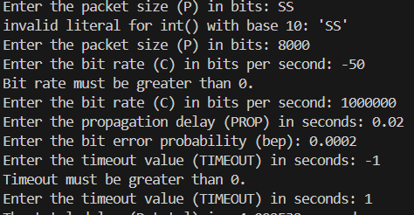

Functions
The script defines two main functions: calculate_total_delay and get_valid_input.
- calculate_total_delay: This function takes the packet size, bit rate, propagation delay, bit error probability, and timeout as inputs and calculates the total delay required to send the packet across the network. It calculates transmission delay and incorporates the impact of bit errors by adjusting for the expected number of retransmissions. It also handles cases where the success probability is very low due to high bit error probabilities by setting a threshold and displaying a warning message.
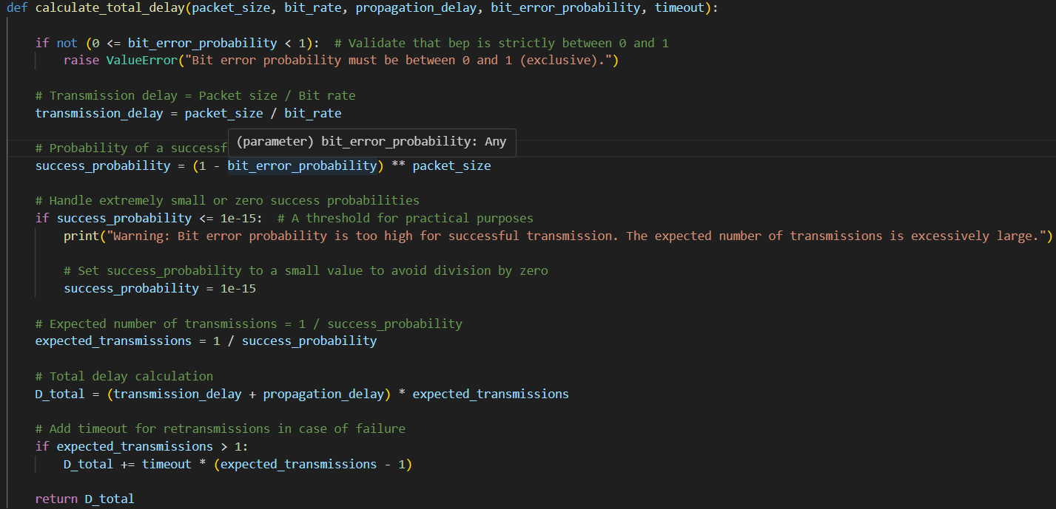
- get_valid_input: This function prompts the user for input and ensures that the provided values meet the required conditions (e.g., packet size and bit rate must be positive, bit error probability must be between 0 and 1). If the user enters invalid input, the function will display an error message and ask for input again.
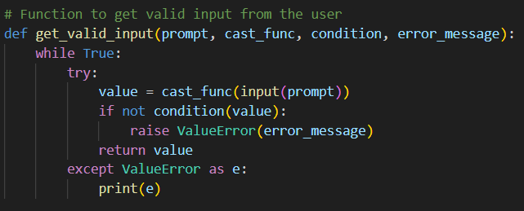

Workflow
The workflow of the script can be broken down as follows:
- User Input: The user is prompted to enter the five required parameters: packet size, bit rate, propagation delay, bit error probability, and timeout. The get_valid_input function ensures that each input is valid, preventing errors in calculations.
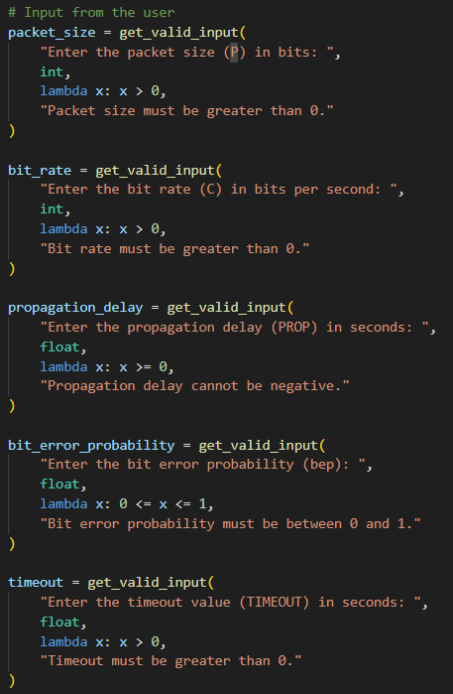

- Delay Calculation: Once all inputs are gathered, the calculate_total_delay function is called. First, the transmission delay is calculated as the packet size divided by the bit rate. Then, the probability of successful transmission is computed based on the bit error probability and the packet size. If the success probability is too low (indicating a high bit error probability), the script displays a warning message and adjusts the success probability to avoid unrealistic transmission times. Using the success probability, the expected number of transmissions is calculated, and the total delay is determined by multiplying the transmission and propagation delays by the expected number of transmissions. If retransmissions are needed, the timeout is added to the total delay.
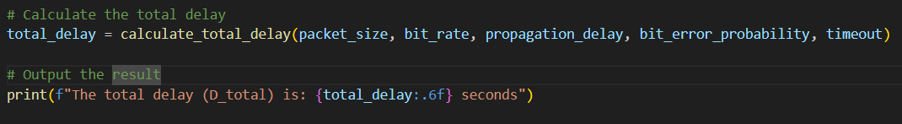
The workflow ensures that the user receives meaningful feedback even in scenarios with high bit error rates, preventing crashes or unrealistic outputs while providing an informative delay estimation.

Output
